Student Name : Goh Zongye Benjamin

Group : SSP1

Date : 29/03/2022

LAB 4: ANALZING NETWORK DATA LOG

You are provided with the data file, in .csv format, in the working directory. Write the program to extract the following informations.

Exercise 4A: TOp TALKERS and LISTENERS

One of the most commonly used function in analyzing data log is finding out the IP address of the hosts that send out large amount of packet and hosts that receive large number of packets, usually know as TOP TALKERS and LISTENERS. Based on the IP address we can obtained the organization who owns the IP address.

List the TOP 5 TALKERS

Rank | IP address | # of packets | Organisation
1 | 193.62.192.8 | 3041 | European Bioniformatics Institute
2 | 155.69.160.32 | 2975 | Nanyang Technological University
3 | 130.14.250.11 | 2604 | National Library of Medicine
4 | 14.139.196.58 | 2452 | Indian Institute of Technology
5 | 140.112.8.139 | 2056 | National Taiwan University

TOP 5 LISTENERS

Rank | IP address | # of packets | Organisation
1 | 103.37.198.100 | 3841 | A*STAR
2 | 137.132.228.15 | 3715 | National University of Singapore
3 | 202.21.159.244 | 2446 | Rpnet
4 | 192.101.107.153 | 2368 | Pacific Northwest National Library
5 | 103.21.126.2 | 2056 | Indian Institute of Technology Bombay

Exercise 4B: TRANSPORT PROTOCOL

Using the IP protocol type attribute, determine the percentage of TCP and UDP protocol

 | Header value | Transport layer protocol | # of packets (% of traffic)
1 | 6 | TCP | 56063 (80.819%)
2 | 17 | UDP | 9462 (13.640%)

Exercise 4C: ApplicationS PROTOCOL

Using the Destination IP port number determine the most frequently used application protocol.
(For finding the service given the port number https://www.adminsub.net/tcp-udp-port-finder/ )

Rank | Destination IP port number | # of packets | Service
1 | 443 | 13423 | HTTPS/SSL
2 | 80 | 2647 | HTTP
3 | 52866 | 2068 | Dynamic Port
4 | 45512 | 1356 | Unassigned
5 | 56152 | 1341 | Dynamic Port

Exercise 4D: Traffic

The traffic intensity is an important parameter that a network engineer needs to monitor closely to determine if there is congestion. You would use the IP packet size to calculate the estimated total traffic over the monitored period of 15 seconds. (Assume the sampling rate is 1 in 1000)

Total Traffic (MB) | 7.722

Exercise 4E: ADDITIONAL ANALYSIS

Top 5 Communication Pairs (Sender->Receiver):

# | Source IP | Source Org | Destination IP | Destination Org | Num of Packets
1 | 193.62.192.8 | European Bioinformatics Institute | 137.132.228.15 | National University of Singapore | 3041
2 | 130.14.250.11 | National Library of Medicine | 103.37.198.100 | A*STAR | 2599
3 | 14.139.196.58 | Indian Institute of Technology | 192.101.107.153 | Pacific Northwest National Library | 2368
4 | 140.112.8.139 | National Taiwan Univeristy | 103.21.126.2 | Indian Institute of Technology Bombay | 2056
5 | 137.132.228.15 | National University of Singapore | 193.62.192.8 | European Bioinformatics Institute | 1910

Visualisation of Captured Network using igraph (web hosted image for better visual clarity):
Nodes are the hosts and edges are the connection, shows top 100 communication pairs
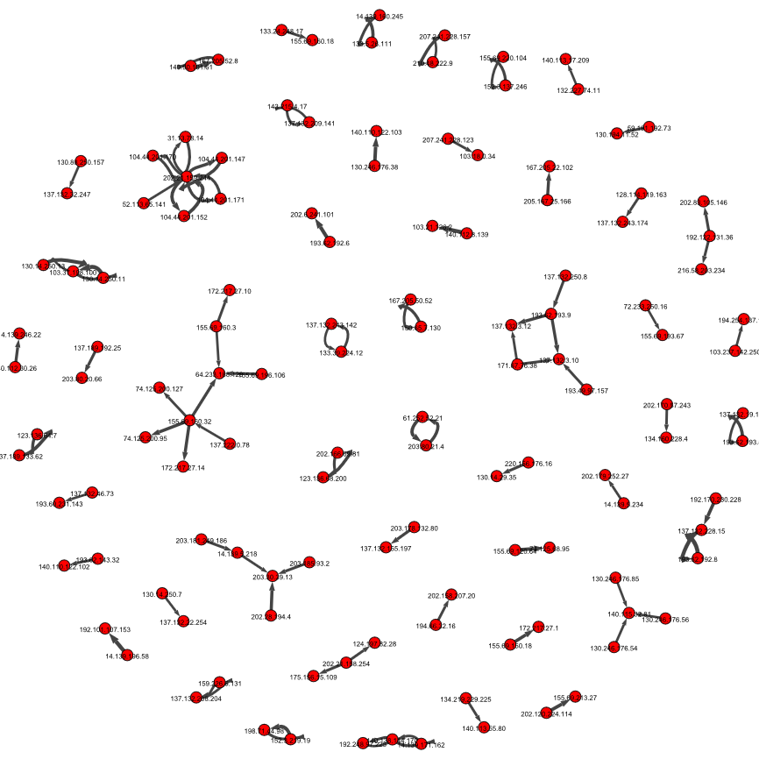
Exercise 4F: SOFTWARE CODE

Please also submit your code to the NTULearn lab site.

